ICCC Quick reference Guide

1. **Login to ICCC**
   1. Login to ICCC as a call taker:
2. Open the application from the desktop of your smart computer.

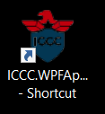

1. Use your normal computer login in the first field, example “Walsalman”.
2. In the second field put your password, default password for all users is 123456.

You need to change this when you start using ICCC.

1. Third field as call taker needs to be left empty.
2. Choose your preferred language.
3. 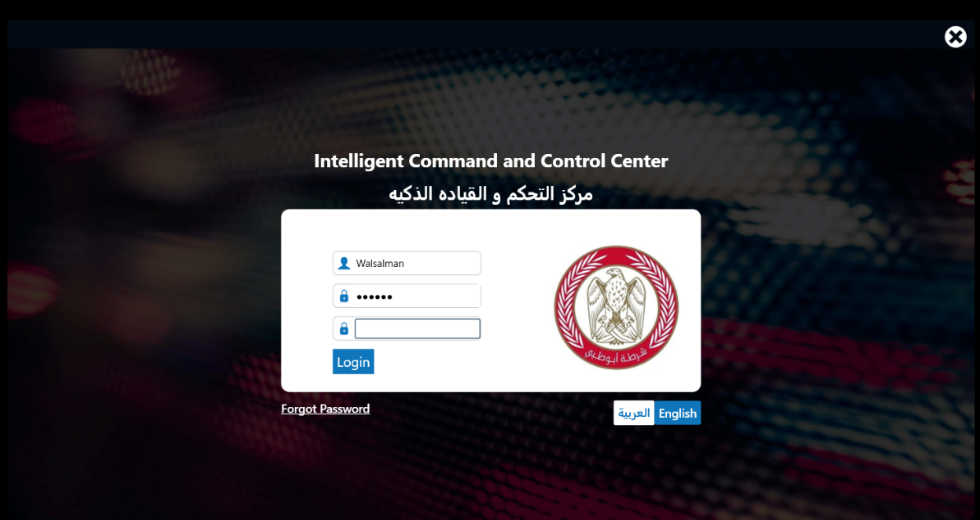Click on login.

1.2 Login to ICCC as a dispatcher:

1. Open the application from the desktop of your smart computer.



1. In the first field use your normal computer login and add “disp” to it then, example “Walsalmandisp”.
2. In the second field put your password, default password for all users is 123456.

You need to change this when you start using ICCC.

1. Third field select all areas.
2. Choose your preferred language.
3. Click on login.

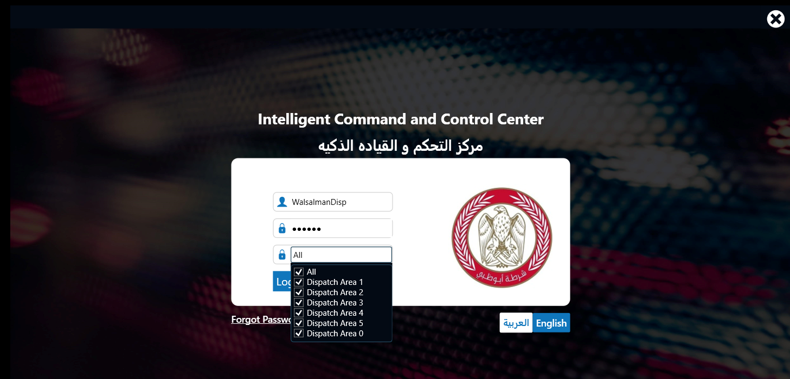

1. **Call taker**
   1. Create new incident:
2. To open new incident, click on “+” on the top left of your call taker screen.

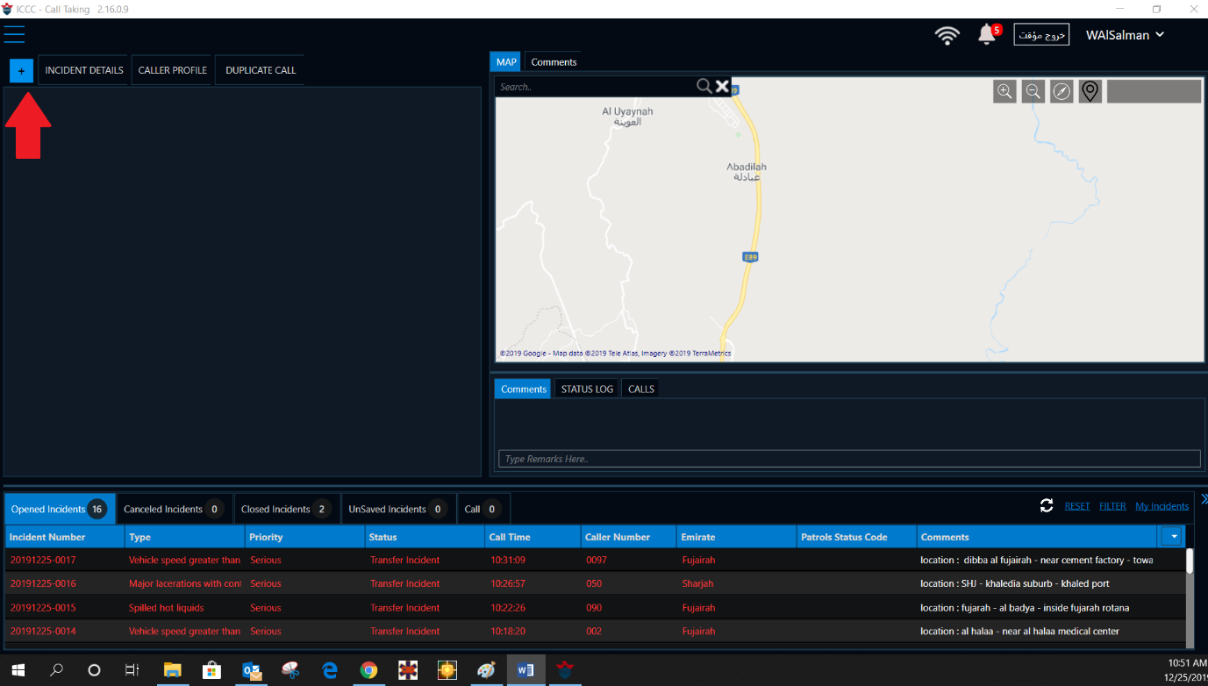

1. Use the search field on the top of the map to search for locations, or you can drop pin directly on the map by double clicking on the area you want to drop the pin in.
2. When you fill the landmark, dropdown list will appear with the suggestions.
3. One you click Enter on the smart keyboard it will give all the suggestions on the maps as red pins.

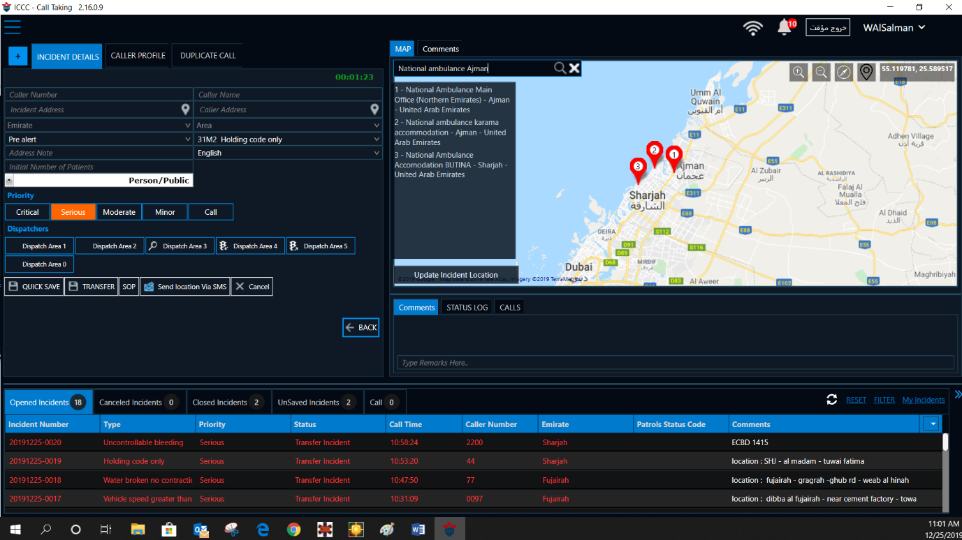

1. Now you will be able to **QUICK SAVE** the incident so the dispatcher can see it.
2. Fill remaining fields: Caller number, caller name, number of patients and address notes.

**Note**: it is very important that the call taker updates the address field because it will appear in the dispatcher list under the Emirate and it will help the dispatcher to differentiate between incidents.

1. From the incident address click Tap on the smart keyboard to fill the caller address with the same address as the incident address.





1. Put the comment in the comment area and click enter on the smart keyboard.
2. Use the Status log to display the incident details from the time the incident created till closing the call.
3. Click on TRANSFER from the left bottom of the call taker screen.

**Note:**

1. there are no mandatory fields to be filled by the call taker Quick save, apart from dropping the pin on the map, the system will auto full fill the mandatory fields.
2. A green counter will automatically start whenever open new incident; the color turns in to red flashing color after 2 minutes if the call not yet saved. The counter will stop counting time whenever the call is saved.

 

* 1. **Filter the incident list:**

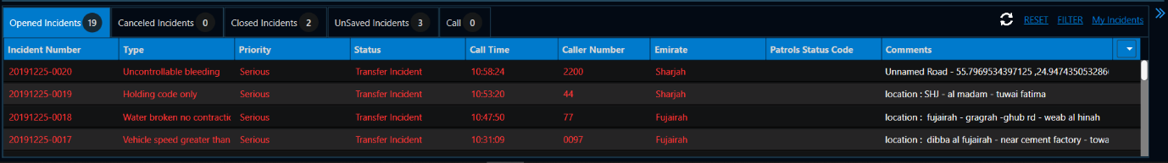There are many ways the call taker incident list can be filtered to.

1. Open incidents, canceled incidents, Closed incidents, unsaved incidents.
2. If you clicked on **MY Incidents** on the far right, it will turn to green color then you will be able to see only the incidents you created.
3. More criteria filtering click on the **FILTER** button and choose the criteria you want to filter to Emirate, time, Date, caller number etc…
   1. **Call taker map**
4. Click on the top left list.

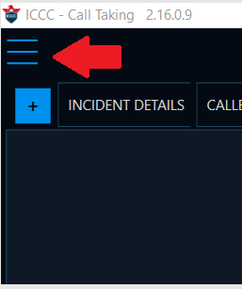

1. Choose the call taker map option.
2. Zoom in the location you need to then double click on the location so it drops pin and open a new incident in the call taker screen.
   1. **Network connection indicator:**

The network connection indicator icon can be seen on the top middle of the call taker screen; the icon represents the following:

1. Strong connection (White color). 
2. Weak connection (Orange color). 
3. No connection (Red color). 
   1. **User Name button:**
      1. App language
4. English
5. Arabic
   * 1. App theme
6. White theme
7. Blake theme
   * 1. 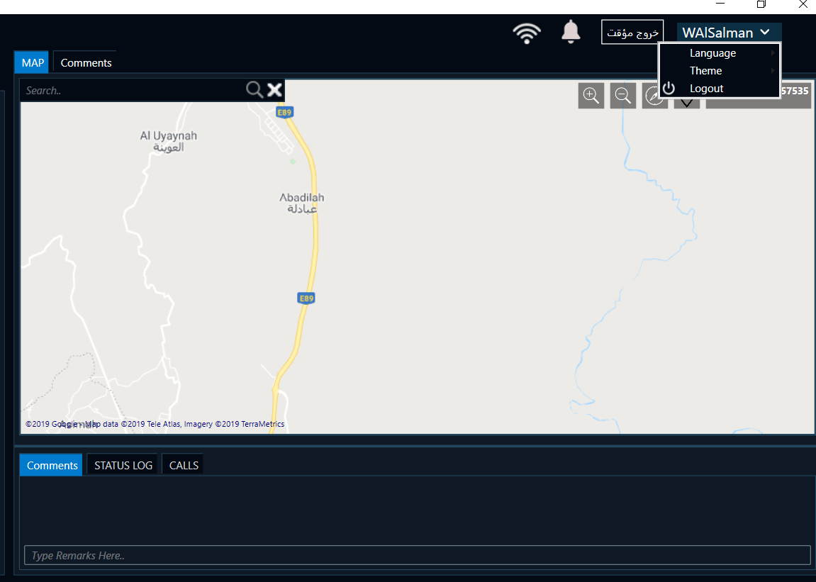Logout
   1. **Search All Incidents**
8. Click on the top left list.



1. Choose search all incidents

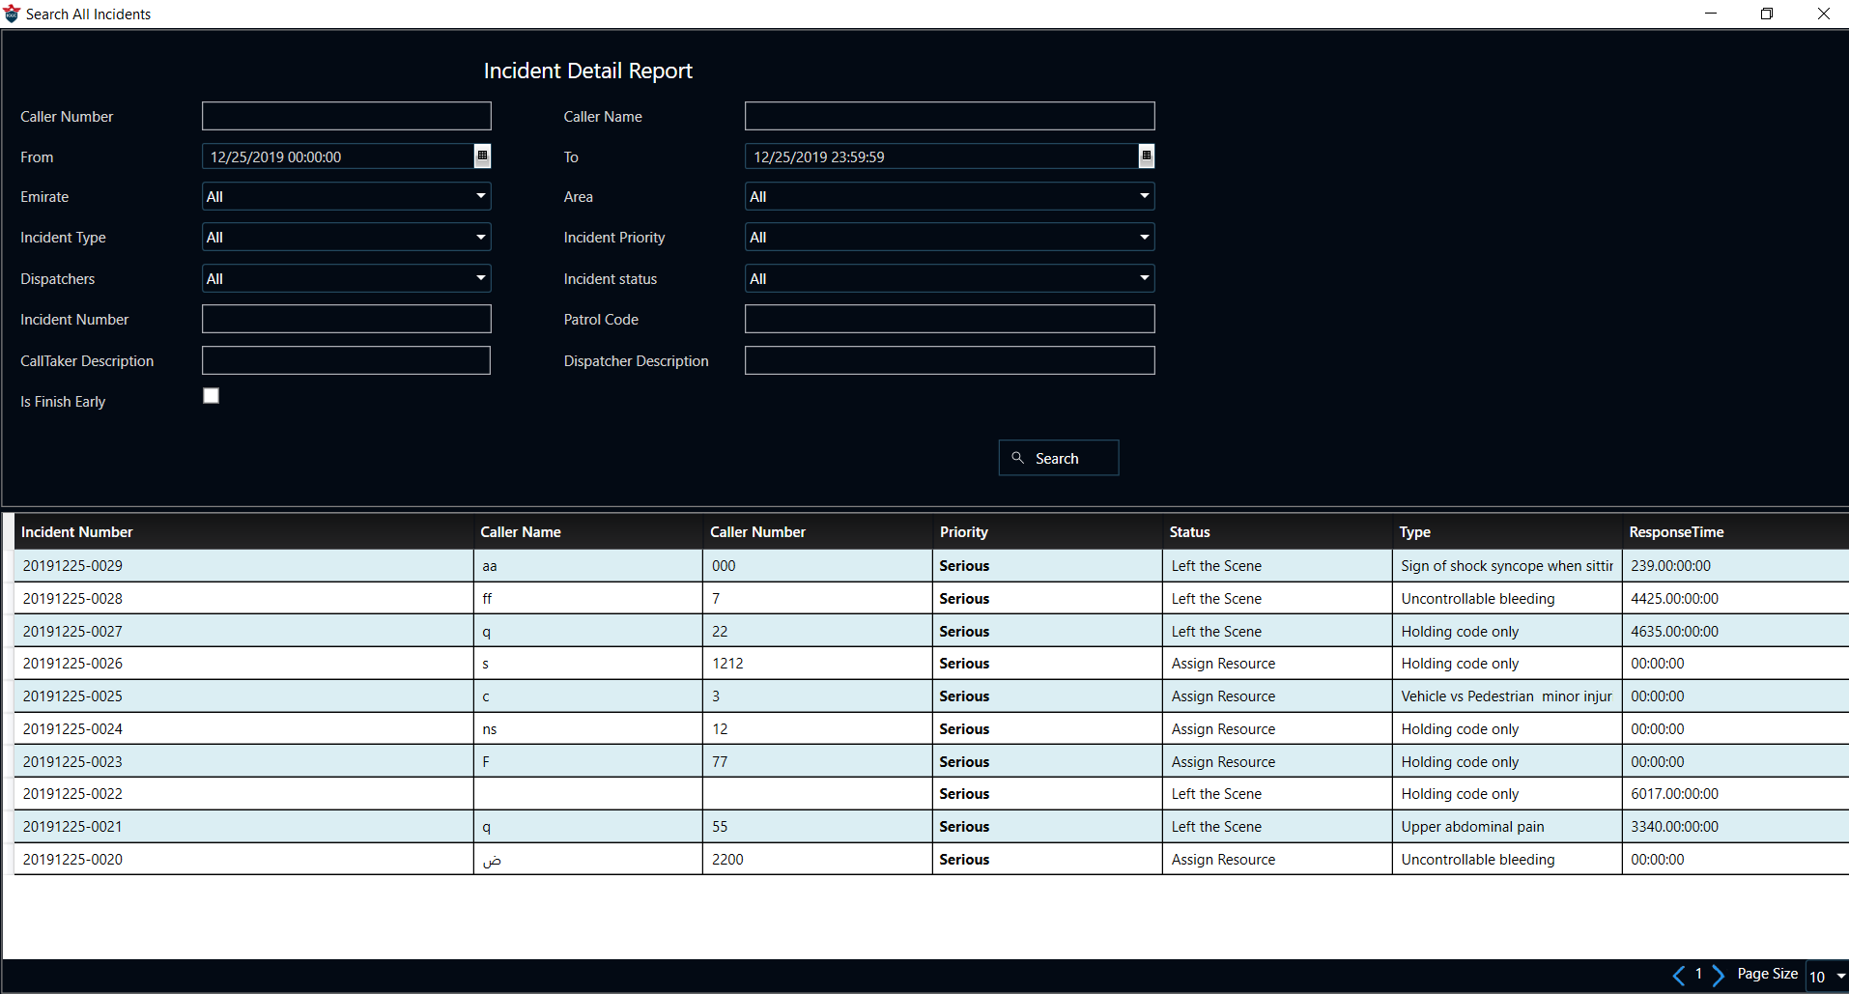

1. The user can search the incidents using the following search fields
2. Time & date.
3. Caller name or number.
4. Emirate
5. Area
6. Call taker description
7. Dispatcher description

Etc…

Note: When search by call taker description or dispatcher description. The description means the ID#, if the user is using their call taker account they only need the ID# in the field. But if using the dispatcher account, you need to add D after, Example 1170D.

* 1. **Dispatcher**
  2. **Dispatcher screen components:**

1. Dispatcher Mapwhich contains:

A.1 Fleet tracker.

A.2 Incidents pins.

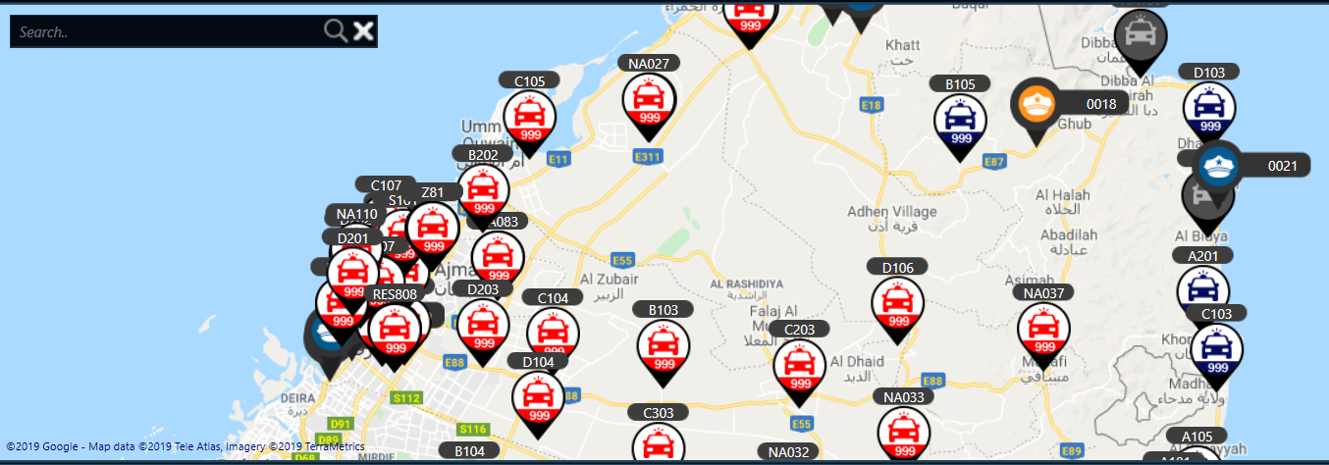

1. New Incidents which contains: All incidents not yet dispatched.
2. Opened Incidents which contains: All incidents already dispatched.
3. Top left listwhich contains:



D.1 Dispatcher map

D.2 Dispatcher Incident list

D.3 Search for All Incidents

* 1. **Dispatching process**
     1. Dispatch the incident without open it

1. One click on the incident of a new incident, the dispatcher map will automatically zoom in the location of the incident you clicked on.

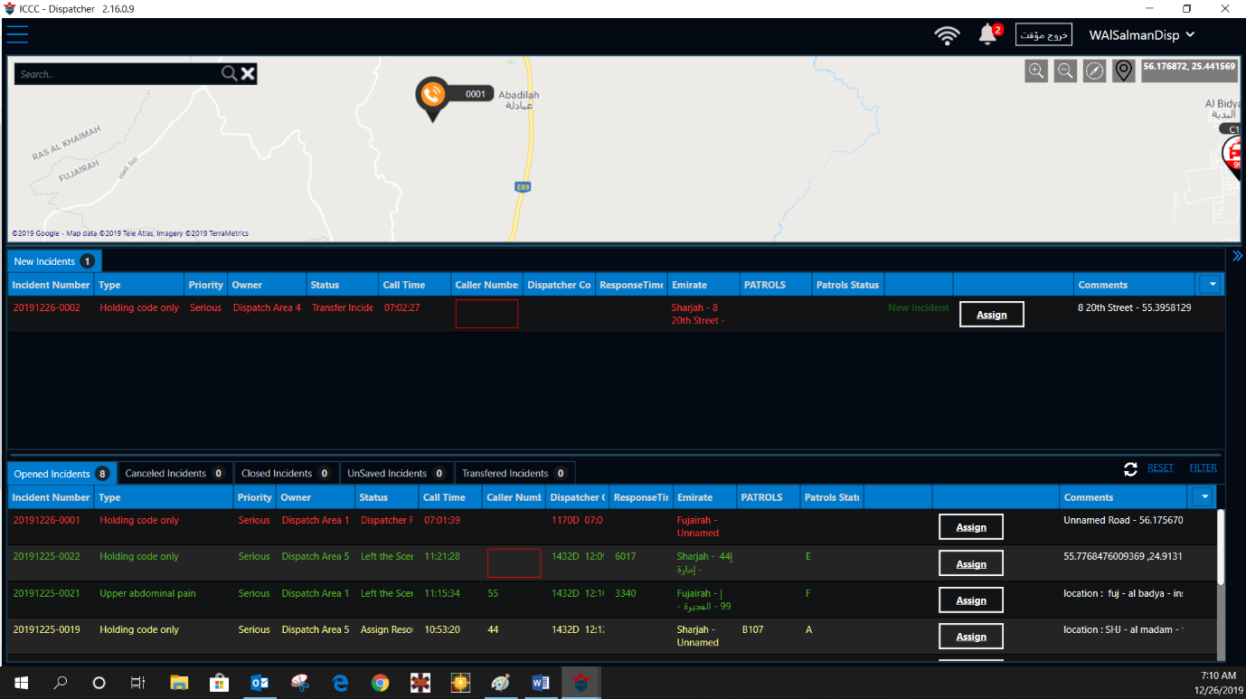

1. Once you know where is the location and decided which is the nearest unit click on **Assign**.
2. Search list will pop up on the right side of your dispatcher screen, from this list search for the unit you want to dispatch then click enter.

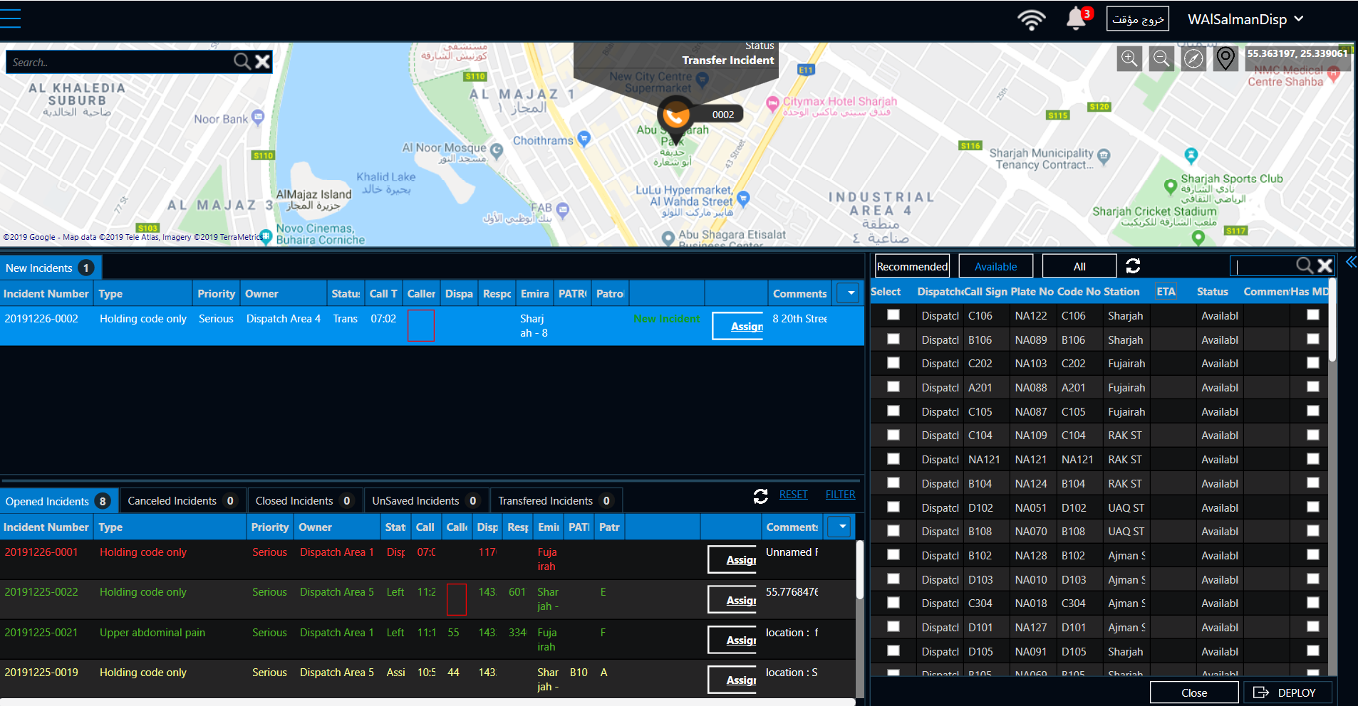

1. **Drag and drop** the unit on the incident you want to dispatch in the incident list **or** click on **DEPOLY**.
   * 1. **Dispatch the incident after you open it**
2. Double click on the incident to open it
3. From the bottom right side search list, search for unit
4. Drag and drop the unit in the empty left field **or** click on **DEPLOY**

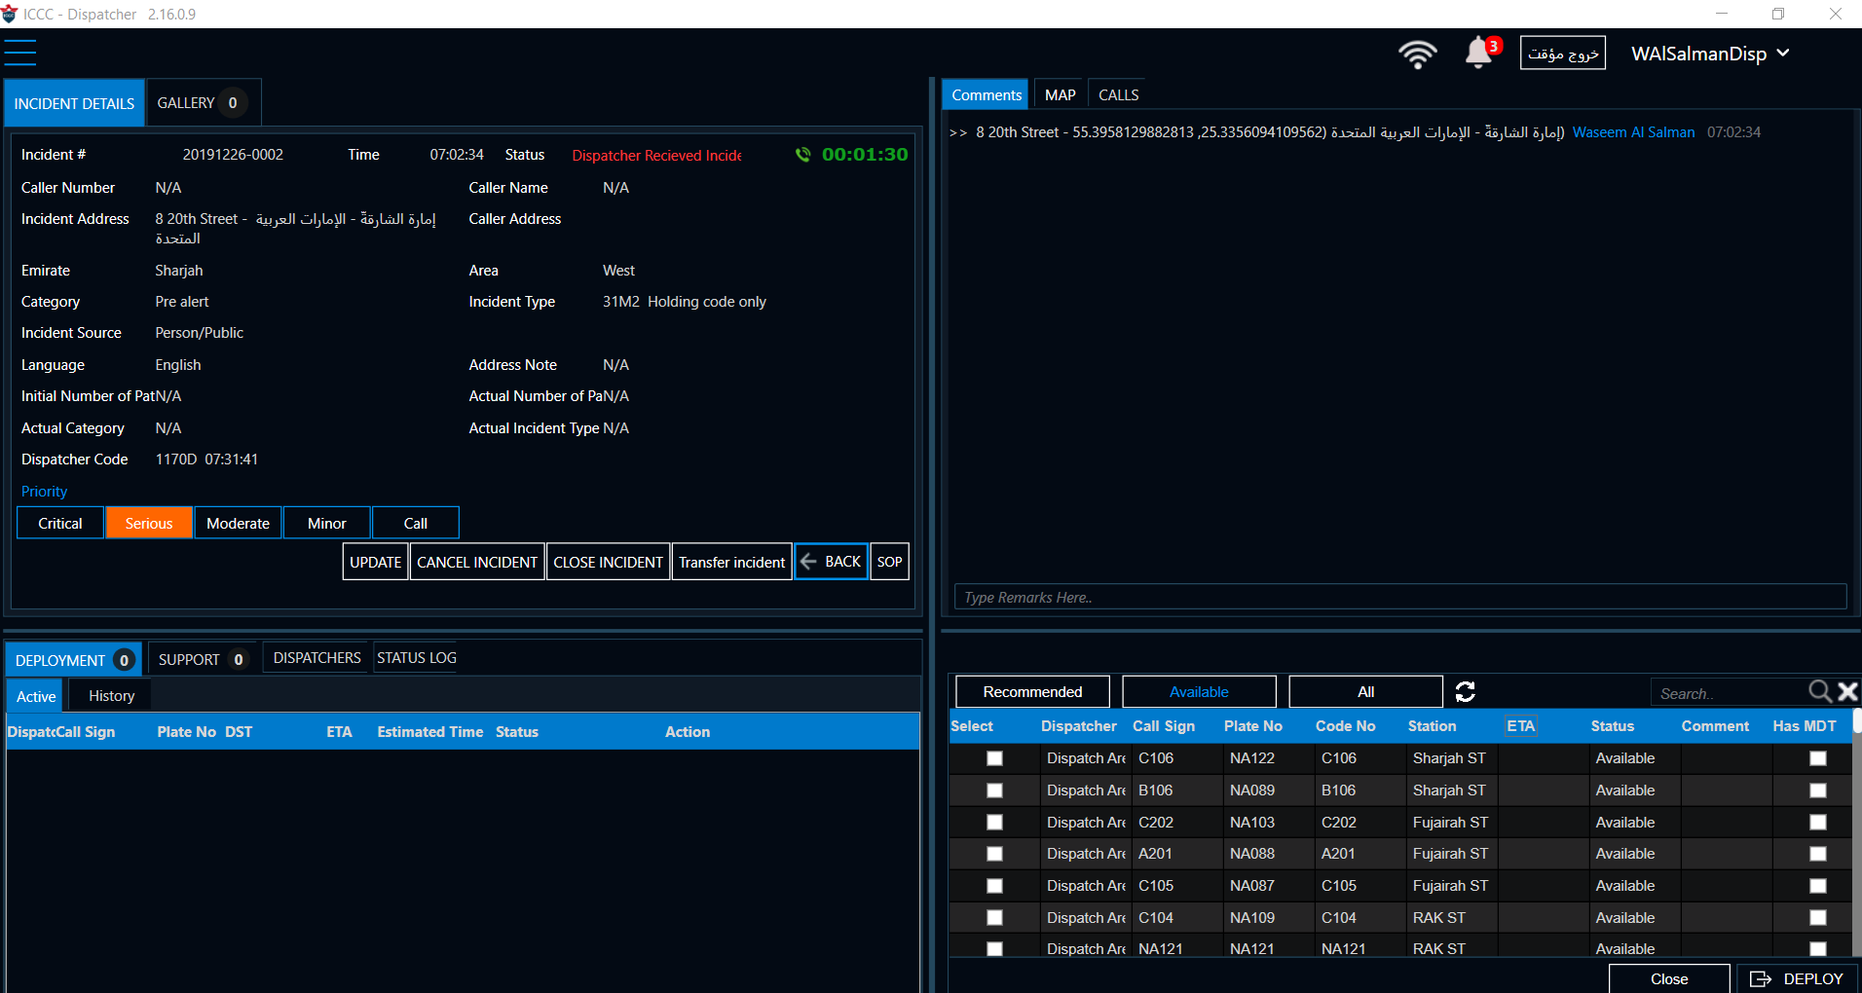

**Note:** The dispatcher no longer need to send the **GPS Coordinates SMS.** The SMS will be auto sent to the unit when the dispatcher assigns the incident, whenever the call taker updates the location and whenever the unit is canceled from the incident.

* + 1. **Update the unit status**

1. Reassign, in order to reassign the unit, do the following:

* Click on cancel from the deployment list
* Update the cancelation reason as reassign
* Confirm

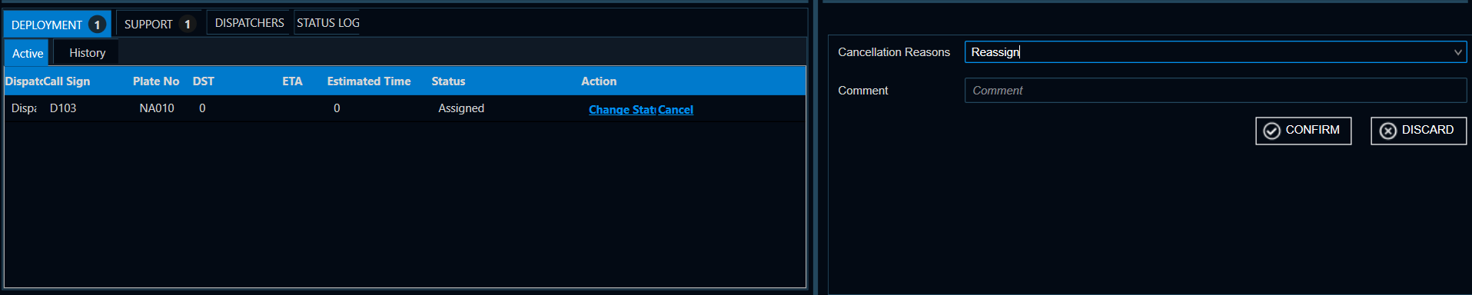

1. Finish early

* Click on change status from the deployment list
* Update the status to Finish Early
* Update the number for the number of transported patients
* Confirm

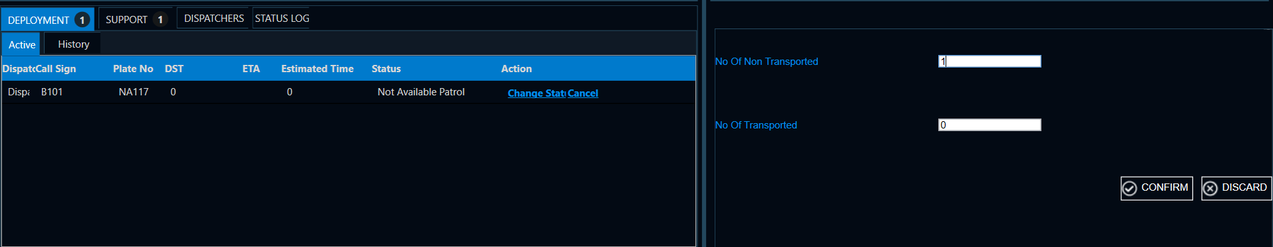

1. Finish

* Click on change status from the deployment list
* Update the status to Finish
* Update the number for the transported patients
* Confirm

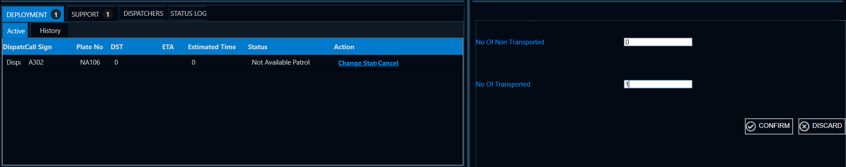

* + 1. **Clear Incident**

1. Cancel Incident

* From Incident details click on **CANCEL INCIDENT**
* Update the cancelation reason
* Confirm

1. Close Incident

* From Incident details update the actual category and the actual incident type
* Click on update
* Click on close incident
* Update the reason to close. If finish early the reason will be refused and if the incident is finished the reason will by event / incident completed.
* Confirm
  + 1. There are many ways the call taker incident list can be filtered.

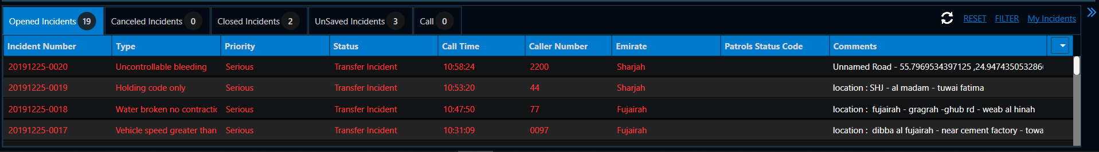

1. Open incidents, canceled incidents, Closed incidents, unsaved incidents.
2. If you clicked on **MY Incidents** on the far right, it will turn to green color then you will be able to see only the incidents you created.
3. More criteria filtering click on the **FILTER** button and choose the criteria you want to filter to Emirate, time, Date, caller number etc…
   * 1. Incidents Colors: the incident color will change depending on the incident status
4. Red Incident: Not yet dispatched
5. Yellow Incident: Assigned, Acknowledged and On Route
6. White Incident: At Scene, At Patient, Transporting and At Hospital
7. Green Incident: Finish Early, Finish
   * 1. Sort the dispatcher incident list by list by

* Click on the arrow on the right side of the list
* Choose the sort criteria
* To do ascending or descending for the criteria double click on it.
* Example to make the list sort by the Status ascending or descending double click on top of the status.

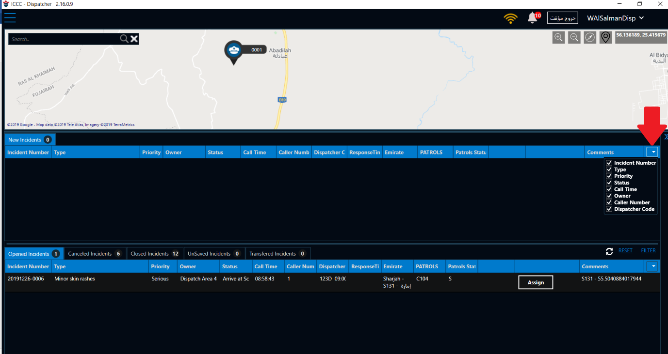

* + 1. Patrol Status 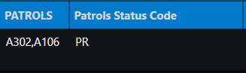
* A: Stands for Assigned
* K: Stands for Acknowledged
* R: Stands for Route
* S: Stands for Scene
* P: Stands for Patient
* E: Stands for Finish Early
* T: Stands for Transporting
* H: Stands for Hospital
* F: Stands for Finish
  + 1. Status Log

Use the Status log to display the incident details from the time the incident created till closing the call.

**ICCC Call Taker Sign Off**

|  |  |  |  |
| --- | --- | --- | --- |
| Name – | | | ID - |
| **Competency** | **Student Signed** | **Tutor Signed** | **Date** |
| Log into ICCC using your call taker account |  |  |  |
| Change the application language |  |  |  |
| Change the application theme |  |  |  |
| Open the call taker map |  |  |  |
| Search for a location in Northern emirates |  |  |  |
| Quick save a call |  |  |  |
| Fulfill all call fields and transfer |  |  |  |
| Insert a new comment and understand how this field works |  |  |  |
| Understand all dispatch areas and which location belong to which dispatch area |  |  |  |
| Open the call status log and check all call timings |  |  |  |
| Create a new call don’t save it then go look for it in the unsaved incidents and transfer it |  |  |  |
| Look for a specific call in the calls history |  |  |  |
| Filter the calls list for only your ones |  |  |  |
| Filter the calls list for as specific criteria |  |  |  |
| Show understanding for the whole process of the call taking using the ICCC |  |  |  |

**Completion**

By signing you agree that you have received sufficient training to be able to operate the ICCC system effectively and that you are aware of all the features within it.

|  |  |
| --- | --- |
| Staff Signature - | Date - |
| Trainer Signature - | Date - |
| Team Leader Signature - | Date - |
| ACC Manager Signature - | Date - |

**ICCC Dispatcher Sign Off**

|  |  |  |  |
| --- | --- | --- | --- |
| Name – | | | ID - |
| **Competency** | **Student Signed** | **Tutor Signed** | **Date** |
| Log into ICCC using your Dispatcher account |  |  |  |
| Change the application language |  |  |  |
| Change the application theme |  |  |  |
| Open the dispatcher map |  |  |  |
| Open the incident list |  |  |  |
| Show all tracking units |  |  |  |
| Assign a call without getting into it using the drag and drop |  |  |  |
| Open unassigned call, assign the nearest unit using the deploy button |  |  |  |
| Reassign an assign incident to another unit |  |  |  |
| Finish an incident |  |  |  |
| Finish early an incident |  |  |  |
| Use the undo button |  |  |  |
| Multi dispatch an incident, cancel one unit, finish one unit early, reassign one unit, finish one unit and close the whole incident |  |  |  |
| Filter the calls list for as specific criteria |  |  |  |
| Look for a specific call in the calls history |  |  |  |
| Open the call status log and check all call timings |  |  |  |
| Insert a new comment and understand how this field works |  |  |  |
| Understand the process of how ICCC send the GPS coordinates |  |  |  |
| Create a call for walk in patient and proceed with it from A to Z |  |  |  |
| Create a call for one of NAC single contacts and proceed with it from A to Z |  |  |  |
| Show understanding for the whole process of the dispatching using the ICCC |  |  |  |

**Completion**

By signing you agree that you have received sufficient training to be able to operate the ICCC system effectively and that you are aware of all the features within it.

|  |  |
| --- | --- |
| Staff Signature - | Date - |
| Trainer Signature - | Date - |
| Team Leader Signature - | Date - |
| ACC Manager Signature - | Date - |

**ICCC Admin Sign Off**

|  |  |  |  |
| --- | --- | --- | --- |
| Name – | | | ID - |
| **Competency** | **Student Signed** | **Tutor Signed** | **Date** |
| Log into ICCC admin website using your admin account |  |  |  |
| Add a new staff member in the **staff list** |  |  |  |
| Deactivate, activate, reset password, change password and change the roles for staff from the **staff list** |  |  |  |
| Create and modify a patrol from **PATROLS LIST**   * Change the call sign * Change the phone number |  |  |  |
| Dismiss or temporary dismiss a patrol from the **PATROLS ATTENDANCE** |  |  |  |
| Attend a patrol from **PATROLS MANUAL ATTENDANCE** |  |  |  |
| Add a new area and modify an existed one |  |  |  |
| Add a new Category (case classification) and modify an existed one |  |  |  |
| Add a new Incident type (case type), modify an existed one and connect it to the right category |  |  |  |

**Completion**

By signing you agree that you have received sufficient training to be able to operate the ICCC system effectively and that you are aware of all the features within it.

|  |  |
| --- | --- |
| Staff Signature - | Date - |
| Trainer Signature - | Date - |
| ACC Manager Signature - | Date - |